**Exploring Continuity**

In simplest terms, a continuous function is one that does not have any “holes”, “gaps” or “jumps”. But there is, in theory, more to this concept.

Consider the function defined by:



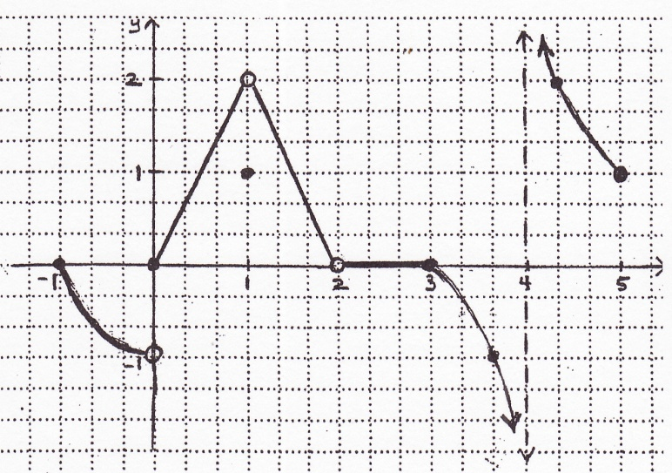

The graph would look like:

|  |  |  |  |  |
| --- | --- | --- | --- | --- |
|  |  |  |  | **Does** |
|  |  |  |  |  |
|  |  |  |  |  |
|  |  |  |  |  |
|  |  |  |  |  |

1. At each point of discontinuity, (c, f(c)) , complete the following table:
2. Now consider the function at a point of continuity such as .



1. Finally, consider the function at a point of continuity such as 



1. What hypothesis can you make about continuity in terms of limits based on your answers to 1-3?